Physics-Aware Lightweight Segmentation for Quantitative Holographic Cell Analysis with Optical Mass Preservation
Usama Ikram¹, Youhyun Kim², and Inkyu Moon^{1,2,*}
^{1.} Department of Artificial Intelligence, DGIST, Daegu 42988, South Korea
^{2.} Department of Robotics & Mechatronics Engineering, DGIST, Daegu 42988, South Korea
*Corresponding author: inkyu.moon@dgist.ac.kr
Abstract
Digital holographic microscopy provides label-free quantitative phase images from which cellular dry mass is obtained by integrating the phase over each cell. Segmentation networks trained with geometric overlap losses do not constrain this integral, so boundary errors propagate into optical-mass estimates. We propose a physics-aware lightweight segmentation framework in which the predicted cell boundary is treated as the measurement domain of the integrated phase. A Physics-Aware Phase Consistency Loss adds phase-mask contrast, boundary-gradient alignment and integrated-phase preservation terms, computed on background-referenced 32-bit phase maps, to a class-weighted Dice loss, and low-rank adaptation (LoRA) adapts lightweight foundation-model encoders to single-channel phase images. On red blood cell phase maps acquired over 47 days of storage, MobileSAM and EdgeSAM were compared at five LoRA ranks with three random seeds per configuration (180 training runs including the loss ablation). Relative to Dice-only training, the physics-aware objective lowered the global integrated-phase error in all 15 architecture-rank combinations and reduced the number of runs that lost a morphology class. MobileSAM (rank 8) reached a mean Dice of 0.810 ± 0.006, a boundary F1 of 0.802 and a global integrated-phase error of 1.32 ± 0.09%; EdgeSAM (rank 32) gave better instance separation (aggregated Jaccard index 0.335 vs 0.262) at about half the latency (10.6 vs 20.4 ms) and one eighth of the GPU memory. Without calibration, per-image dry mass from predicted masks agreed with annotation-derived values within a median absolute relative error of 2.9% (MobileSAM) and 3.9% (EdgeSAM). Annotation-derived dry mass showed no storage trend while projected cell area decreased by 44%; the predicted masks reproduced the area change and the morphological composition but added a small storage-dependent dry-mass bias, which identifies instance separation as the remaining limitation for optical-mass aalysis.
Index Terms—Quantitative Digital Holographic Microscopy, Quantitative Phase Imaging, Physics-Aware Segmentation, Optical Mass Preservation, Lightweight Deep Learning.
- Introduction
Holography was introduced by Dennis Gabor in 1947 as a two-step process of recording and reconstructing an optical wavefront, which he called microscopy by reconstructed wavefronts [1] and for which he received the Nobel Prize in Physics in 1971 [2]. His in-line geometry gave reconstructions of limited quality because the virtual image, the conjugate real image, and the transmitted wave reach the observer together [2]. Leith and Upatnieks resolved this twin-image problem with the off-axis hologram, in which the object and reference waves reach the recording plane along directions separated by a finite angle and which, combined with laser illumination, extended holography to three-dimensional objects [2, 3].
Digital recording followed advances in electronic detection and computation. Goodman and Lawrence demonstrated digital image formation from electronically detected holograms in 1967 [4], and Schnars and Jueptner recorded holograms directly on a CCD target and reconstructed them numerically in 1994 [5]. In digital holography (DH), the photosensitive emulsion is replaced by a CCD or CMOS image sensor, the sampled interference pattern is stored as a digital hologram, and the object field is recovered by numerical propagation rather than by optical reconstruction [6, 7]. Because DH requires no imaging lens [8] and reconstructs both the amplitude and the phase of the object wave [9], it provides direct quantitative access to the optical field.
Applied to microscopy, DH is known as digital holographic microscopy (DHM) [9], which combines digital holography with optical microscopy to provide wide-field, label-free quantitative phase microscopy of transparent and semi-transparent specimens [10]. A DHM system consists of a light source, an interferometer containing a microscope objective, a digital image sensor, and a computer for hologram storage and processing [6], and the approach has been applied to biological specimens since early in-line implementations [11, 12]. Because a single hologram contains information describing the microscopic volume, numerical reconstruction permits refocusing at different depths, which makes the technique non-destructive and well suited to living cells [13, 14].
Quantitative phase imaging (QPI) uses the refractive index of the specimen as an endogenous imaging contrast and represents the measured data as quantitative maps of the optical path length delay introduced by the sample [15, 16, 17]. Operating on unlabelled specimens, it avoids photobleaching and exhibits lower phototoxicity than fluorescence microscopy [15, 18]. The phase measured at each pixel is the integral of the refractive index difference between the cell and its surrounding medium through the cell thickness, and refractive index is related to mass through the specific refractive increment, whose typical average value for cells is 0.18 to 0.20 mL/g [19]. The measured phase is therefore proportional to the cellular content excluding water, the cellular dry mass [15, 19], a relationship in use since the 1950s for label-free measurement of cell growth [19, 20, 21]. Because dry mass is obtained by integrating the phase over the cellular region, the boundary that defines this region determines the accuracy of the measurement.
This is particularly valuable in hematological analysis, where red blood cell (RBC) morphology reports on cellular integrity during storage [22]. In stored blood, healthy discocytes are progressively transformed into echinocytes and then into spherocytes, a process termed the RBC storage lesion [23, 24], accompanied by a loss of cell surface area and surface-to-volume ratio [25] and by weakened deformability [23]. Over a 42-day storage period the proportion of discocytes decreases while that of echinocytes and spherocytes increases [24], so the morphology distribution is used to evaluate the quality of stored blood [23]. DHM has quantified three-dimensional geometric and chemical changes of single RBCs during the storage lesion [25], and deep learning has been combined with label-free DHM to assess storage lesions automatically, for which reliable segmentation of individual cells is a prerequisite [26].
Segmentation is regarded as mandatory for the quantitative analysis of QPI data [27]. Conventional image-processing pipelines are affected by background phase variations, holographic artifacts, and weak phase transitions near adjacent cells, and they require several processing stages and careful parameter adjustment to extract a single cell [26]; the Empirical Gradient Threshold method, distance-transform processing, and marker-controlled watershed segmentation have been used for this purpose [28, 29, 30]. Learning-based methods delineate complex boundaries more flexibly, with U-Net style encoder-decoder networks as established baselines [27], and AI-assisted segmentation supports automated tasks such as cell counting and biophysical parameter quantification [16].
Lightweight segmentation models are attractive for quantitative biomedical imaging because they reduce inference latency and memory requirements while retaining the spatial resolution needed for accurate boundary localization [31]. MobileNet-UNet replaces a heavyweight encoder with a MobileNetV2 backbone, using depthwise separable convolutions and inverted residual bottlenecks [32]. Among foundation models, MobileSAM replaces the image encoder of the Segment Anything Model (SAM) with TinyViT by decoupled distillation while retaining the mask decoder [33], and EdgeSAM distils SAM into a RepViT architecture with a prompt-in-the-loop strategy that preserves prompt-to-mask interactions [34].
Because full-network adaptation of large, pre-trained models is computationally expensive and prone to overfitting on limited biomedical data, parameter-efficient fine-tuning updates only a small task-specific subset of parameters, through approaches such as BitFit, structural adapters, and Visual Prompt Tuning [35]. Low-Rank Adaptation (LoRA) adds trainable low-rank decomposition matrices to selected modules, adapting the model while largely preserving the pre-trained representation [36].
Despite these advances, an important limitation remains. Cross-Entropy and Dice, the standard objectives for biomedical segmentation [27], optimize spatial classification or geometric overlap and place no explicit constraint on the quantitative phase enclosed by the predicted cell boundary [37]. In QPI, however, that boundary is not only a geometric contour but the measurement domain over which the phase is integrated, so a prediction can achieve high geometric overlap while still introducing an error in the integrated phase that propagates into phase-derived quantities such as cellular dry mass [37]. This distinction between a geometric segmentation boundary and a quantitative measurement boundary motivates objectives that explicitly preserve the phase-integrated optical information enclosed by the predicted region, a requirement referred to here as optical-mass preservation.
A second limitation concerns domain adaptation and computational cost. Lightweight and foundation vision models are pretrained on natural RGB datasets [38], whereas quantitative phase images are single-channel distributions whose values represent optical phase rather than color and reflectance [39], so direct transfer can be suboptimal, while unrestricted full fine-tuning on small and imbalanced datasets risks overfitting and the degradation of minority morphological classes. Large models such as the original SAM also impose computational and memory requirements that limit their use in resource-constrained environments [33, 40, 41, 42], and deep learning applied to holographic data, although much faster than iterative reconstruction, requires substantial computational resources and training data [43].
This work addresses these limitations with a physics-aware lightweight segmentation framework. We introduce a Physics-Aware Phase Consistency Loss that incorporates quantitative phase information into the segmentation objective through three complementary constraints: Phase-Mask Contrast (PMC), a global constraint on foreground localization based on cell-to-background phase contrast; Boundary-Gradient Alignment (BGA), which encourages predicted boundaries to follow spatial phase transitions; and Integrated-Phase Preservation (IPP), which explicitly constrains the quantitative phase integrated within the predicted cellular region. Raw, unnormalized phase values are supplied directly to this objective so that the preserved physical quantity is not altered by input normalization. LoRA then adapts lightweight models pretrained on natural images to the holographic phase domain with most parameters frozen, which also regularizes training on a small, imbalanced dataset.
Three representative lightweight architectures, MobileNet-UNet [32], MobileSAM [33], and EdgeSAM [34], are evaluated on quantitative phase images of red blood cells recorded over a 47-day storage period, so that segmentation accuracy, integrated-phase preservation, and computational efficiency can be compared across convolutional, transformer-based, and hybrid designs.
- Method
  - Overall Framework
The proposed framework treats the predicted cell boundary as a quantitative measurement domain rather than as a purely geometric contour. As illustrated in Fig. 1, the pipeline consists of four main stages: standardization of the quantitative phase maps, segmentation by a LoRA-adapted lightweight network, optimization with the Physics-Aware Phase Consistency Loss, and extraction of phase-derived cellular measurements.
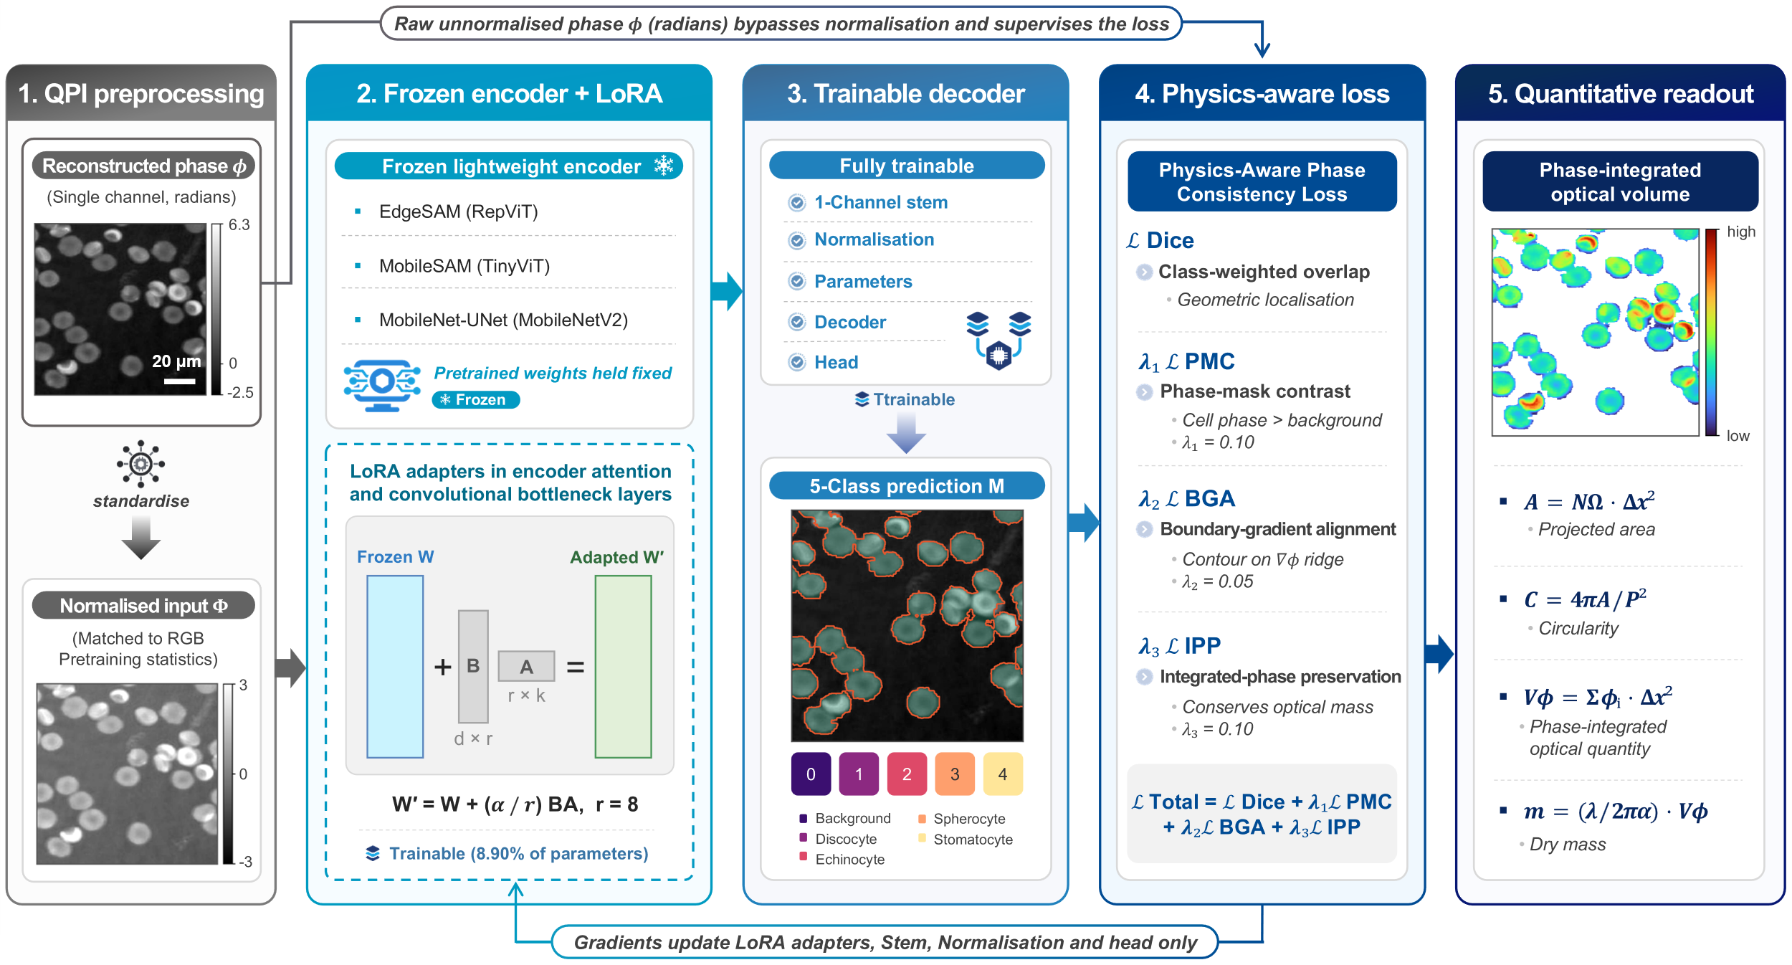
Fig. 1 Overview of the proposed physics-aware lightweight segmentation framework for quantitative holographic cell analysis. LoRA-adapted lightweight networks perform cell segmentation from quantitative phase images, while raw unnormalized phase information is directly incorporated into the Physics-Aware Phase Consistency Loss through the PMC, BGA, and IPP constraints. The resulting segmentation masks serve as physically meaningful measurement domains that preserve phase-integrated optical information for subsequent quantitative cellular analysis.
  - QPI Preprocessing
The input data consist of single-channel quantitative phase maps, reconstructed as 32-bit floating-point arrays in radians. These maps represent the quantitative phase delay associated with the optical path difference introduced by the cells. Because the measured phase depends jointly on refractive-index contrast and specimen thickness, it is treated as an optical phase quantity rather than as a direct measurement of geometric cell thickness or volume. Ground-truth semantic masks contain five discrete classes: background, discocyte, echinocyte, spherocyte, and stomatocyte.
To adapt the single-channel phase maps to segmentation networks originally pretrained on RGB images, phase normalization is applied strictly for numerical stability during forward propagation. The raw phase values are retained separately and are never replaced by the normalized values when evaluating the physics-aware constraints. Spatial resizing and cropping are performed to standardize the network input dimensions.
Data augmentation is restricted to transformations that preserve the quantitative phase values and cellular morphology. Rotation, horizontal and vertical flipping, and translation are therefore applied offline before training. Intensity perturbations, nonlinear contrast transformations, and phase-value modifications are excluded because they could alter the quantitative optical information that the proposed framework is designed to preserve.
  - Lightweight Segmentation Models
Three lightweight architectures are evaluated, covering convolutional, transformer-based, and hybrid designs. MobileNet-UNet pairs an ImageNet-pretrained MobileNetV2 encoder with a U-Net-style decoder with skip connections, which retains the fine spatial information required for accurate cellular boundary delineation [32]. MobileSAM and EdgeSAM retain the mask-decoding pipeline of the original SAM, with the heavyweight ViT-H encoder replaced by a distilled TinyViT backbone and a RepViT backbone respectively [33, 34]. EdgeSAM is evaluated as a computationally efficient architecture rather than as evidence of embedded deployment.
  - LoRA-Based Lightweight Adaptation
LoRA is employed to adapt pretrained lightweight segmentation networks to the distinct statistical and structural characteristics of holographic phase images. For a pretrained weight matrix W, the adapted weight is expressed as:
$W'=W+(B⋅A)×\frac{α}{r}$ , (1)
where W is the frozen pretrained weight matrix, B and A are trainable low-rank matrices, r is the rank of the low-dimensional adaptation space, and α is a scaling factor. To evaluate the balance between adaptation capacity and parameter efficiency, LoRA rank-sweep experiments are performed using the ranks specified in the experimental protocol.
LoRA modules are inserted into architecture-dependent layers. For transformer-based encoders, low-rank matrices are introduced into the query and value projection layers, whereas convolutional bottleneck layers are adapted for CNN-based backbones. To address the structural domain shift from three-channel natural images to single-channel quantitative phase maps, the modified single-channel input stem and normalization parameters are fully unfrozen. The segmentation decoder and final projection heads also remain trainable to generate the five-class RBC segmentation output. Because the decoder and output heads remain trainable, the fraction of trainable parameters differs among architectures.
  - Physics-Aware Phase Consistency Loss
Conventional segmentation objectives optimize geometric agreement between predicted and annotated masks but do not explicitly constrain the quantitative phase signal enclosed by the predicted boundary. In QPI, however, the predicted mask defines the spatial domain over which phase information is integrated for subsequent biophysical analysis. We therefore introduce a Physics-Aware Phase Consistency Loss that combines geometric segmentation with constraints derived directly from the quantitative phase distribution.
    - Multi-Class Dice Loss
To mitigate class imbalance among rare morphology degradation types (e.g., stomatocytes) and ensure numerical stability during mixed-precision (FP16) training, the baseline biological segmentation loss is defined as a class-weighted, smoothed Multi-Class Dice Loss:
$L_{Dice}=\frac{1}{\sum_{c=0}^{4}{w_{c}}}\sum_{c=0}^{4}{w_{c}}\left(1-\frac{2|P_{c}∩G_{c}|+1}{|P_{c}|+|G_{c}|+1}\right)$, (2)
where $w_{c}∈\{0.5,1.0,1.5,2.0,2.0\}$ correspond to the background and the four morphology classes, respectively. A Laplace smoothing factor of $+1$ prevents zero division on background-only patches.
    - Phase-Mask Contrast Term
To ensure the predicted cell region physically maintains higher phase values than the surrounding medium, the contrast term penalizes predictions where the mean background phase exceeds the mean cell phase by a predefined margin:
$L_{PMC}=\text{max}(0,μ_{bg}-μ_{cell}+\text{margin})$, (3)
where $μ_{cell}$ and $μ_{bg}$ denote the mean phase values inside the predicted cellular foreground and the surrounding background, respectively. This term provides a global physical constraint on foreground localization but does not by itself guarantee accurate cellular boundaries.
    - Boundary-Gradient Alignment Term
Because probabilistic network outputs $[0,1]$ and physical phase measurements exist on fundamentally incompatible scales, spatial gradient magnitudes for both the predicted mask ($∇M$) and the raw phase map ($∇Φ$) are first max-normalized per-sample to a $[0,1]$ scale. The segmentation boundary is then structurally aligned with strong phase gradients via an $L_{1}$ penalty:
$L_{BGA}={∥\frac{∇M}{\text{max}(∇M)+ϵ}-\frac{∇Φ}{\text{max}(∇Φ)+ϵ}∥}_{1}$. (4)
This term geometrically anchors the predicted measurement boundary to phase transitions present in the measured QPI data.
    - Integrated-Phase Preservation Term
The key quantitative constraint of the proposed framework is preservation of the phase signal integrated over the segmented cellular domain. For a raw quantitative phase map φ_{i}, predicted foreground probability M_{i}, and ground-truth foreground mask G_{i}, the predicted and reference integrated phase quantities are $S_{pred}=\sum_{i}{M_{i}{}_{i}},$ $S_{GT}=\sum_{i}{G_{i}{}_{i}}$. The IPP loss is then defined as the ground-truth-normalized relative error:
$L_{IPP}=\frac{\left|S_{pred}-S_{GT}\right|}{\left|S_{GT}\right|+ϵ}.$ (5)
The relative formulation improves numerical stability during mixed-precision training and makes the penalty insensitive to the absolute scale of the phase integral. The IPP term directly constrains the integrated phase quantity used in subsequent optical-mass analysis. Under the conventional specific refractive increment assumption, this quantity is proportional to cellular dry mass; therefore, preserving the integrated phase during segmentation directly improves the reliability of downstream dry-mass estimation.
    - Final Loss Function
The final objective combines the biological segmentation task with the three physics-aware constraints:
$L_{total}=L_{Dice}+λ_{1}L_{PMC}+λ_{2}L_{BGA}+λ_{3}L_{IPP}$ , (6)
where $λ_{1}$, $λ_{2}$, and $λ_{3}$ control the relative contributions of the PMC, BGA, and IPP terms, respectively. All physics-aware terms are evaluated using the binary cellular foreground probability rather than individual morphology classes. This separates the morphological classification objective from the physical requirement that the total cellular measurement domain be accurately preserved. As demonstrated by the ablation experiments, the individual constraints are complementary: PMC provides coarse phase-based foreground localization, BGA anchors the predicted boundary to phase transitions, and IPP ensures preservation of the integrated quantitative phase information.
  - Quantitative Phase-Derived Cellular Measurements
The principal purpose of the proposed physics-aware segmentation is to enable reliable quantitative cellular measurements from the predicted mask. For each connected cellular component, we therefore extract projected area, circularity, integrated phase, and dry mass. The projected area is calculated as:
$A=N_{Ω} Δx_{\text{eff}}^{2}$ , (7)
where N_{Ω} is the number of pixels in Ω , and Δx_{eff} is the effective object-plane pixel pitch, defined as the camera pixel pitch divided by the system magnification. For the imaging system used in this study, Δx_{eff} = 0.1441 μm/px, and the projected area is therefore expressed in μm². Cell circularity is defined as:
$C=\frac{4πA}{P^{2}}$ , (8)
where P denotes the perimeter of the segmented component. Circularity characterizes the two-dimensional projected outline of a cell, while complementary phase information reflects variations in the cell’s optical thickness profile. The central optical quantity used in this study is the integrated phase over the segmented cellular domain:
S=i∈Ω​i Δxeff2 , (9)
Here, S_{φ} represents the area-integrated quantitative phase associated with the cell, incorporating the coupled contributions of refractive-index contrast and optical thickness. It serves as the primary phase-derived optical quantity whose preservation is explicitly enforced by the IPP loss. Under the conventional assumption that cellular refractive-index increment is approximately proportional to dry-mass concentration, cellular dry mass can be estimated from the integrated phase as:
$m=\frac{λ}{2πα}S_{}$ , (10)
where λ is the illumination wavelength and α is the specific refractive increment of cellular solids. In this study, λ = 666 nm and α = 0.2 mL/g were used, with the latter corresponding to the specific refractive increment for haemoglobin-dominated RBCs. Equations (9) and (10) establish the physical motivation for optical-mass preservation in the proposed segmentation framework: errors in the predicted measurement boundary alter the integrated phase and therefore propagate directly into dry-mass estimates. The proposed loss consequently optimizes segmentation not only for geometric agreement but also for preservation of the phase-integrated information required for quantitative biophysical analysis.
Per-cell measurements are obtained through connected-component labeling of the predicted foreground at the native patch resolution. Components outside the predefined projected-area range are excluded to remove isolated pixel artifacts and unresolved multi-cell clusters. Cell perimeter is calculated using the Crofton estimator to reduce sensitivity to pixelation. For dry-mass estimation, the background phase level is estimated from the non-cellular region of each quantitative phase map and subtracted to remove residual image-wise phase offsets. The integrated phase is converted to cellular dry mass using Eq. (10), with the phase scale calibrated to the mean corpuscular hemoglobin (MCH) reference. No background correction is applied when computing the segmentation loss or the global Integrated-Phase Error (IPE); both operate directly on the raw phase values. Background-phase compensation is applied at the dry-mass estimation stage described above and in the per-cell IPE statistic of Section 3.3.2.
- Experiments
  - Dataset and Imaging Configuration
The experimental evaluation was designed to assess three core aspects of the proposed framework: (1) multi-class segmentation accuracy across different RBC morphologies, (2) preservation of quantitative phase information and optical-mass-related measurements, and (3) computational efficiency of the lightweight segmentation architectures. The framework was evaluated using a dataset of single-channel quantitative phase images acquired with a DHM system during long-term blood storage experiments [26, 44]. Blood samples (2 mL each) were collected from three healthy donors under a protocol approved by the Institutional Review Board of DGIST (Approval No. DGIST-180713-BR-012-01), with the same samples imaged repeatedly over the storage period. The quantitative phase maps were numerically reconstructed from off-axis holograms and represent the phase delay associated with the optical path difference introduced by the RBCs. The dataset comprises 1,090 densely annotated images acquired at eleven time points over 47 days of blood storage (days 0, 5, 8, 12, 15, 19, 23, 27, 30, 37, and 47), thereby capturing progressive storage-induced morphological changes in RBCs. The ground-truth semantic masks contain five classes: (1) background, (2) discocyte, (3) echinocyte, (4) spherocyte, and (5) stomatocyte. Cells were manually annotated and classified by an expert biologist using representative example morphologies as classification criteria. Cells were segmented into multi-label masks, and overlapping cells were separated into individual instances using a distance transform of the mask thresholded at 0.3 to construct binary marker maps. No cells superposed along the optical axis were identified among the annotated cells: the cells with the highest phase per pixel relative to the typical cell in the same image were single, optically dense cells rather than superposed pairs. Laterally touching cells and unresolved multi-cell clusters, which were most frequent at day 15, are discussed in Section 4.8. To provide sufficient training data while maintaining a separate validation set for evaluation, the dataset was divided into 1,024 training images and 66 validation images, corresponding to six validation patches at each storage time point. The quantitative phase maps were used directly, without further normalization, for integrated-phase and dry-mass calculations.
Holograms were recorded with an off-axis transmission digital holographic microscope based on a Mach-Zehnder interferometer [26, 44], as shown in Fig. 2. The light source was a 666 nm laser diode. The sample was imaged with a 40×/0.75 NA microscope objective onto a CCD sensor (11.3 mm × 7.1 mm, 1920 × 1200 pixels of 5.86 µm × 5.86 µm, of which 1024 × 1024 pixels were used). The field of view was approximately 140 µm, with an effective pixel size at the sample of 0.1441 µm. The object wave was reconstructed numerically: the +1 diffraction order was isolated by spatial filtering in the Fourier domain to remove the zero order and twin image, and the phase was recovered using a Fresnel-approximation numerical diffraction calculation. Background phase aberrations were corrected using a numerical phase mask fitted to a fringe-free reference region of each hologram. Phase unwrapping was applied during reconstruction, and no annotated cell exceeded a phase of 2π.
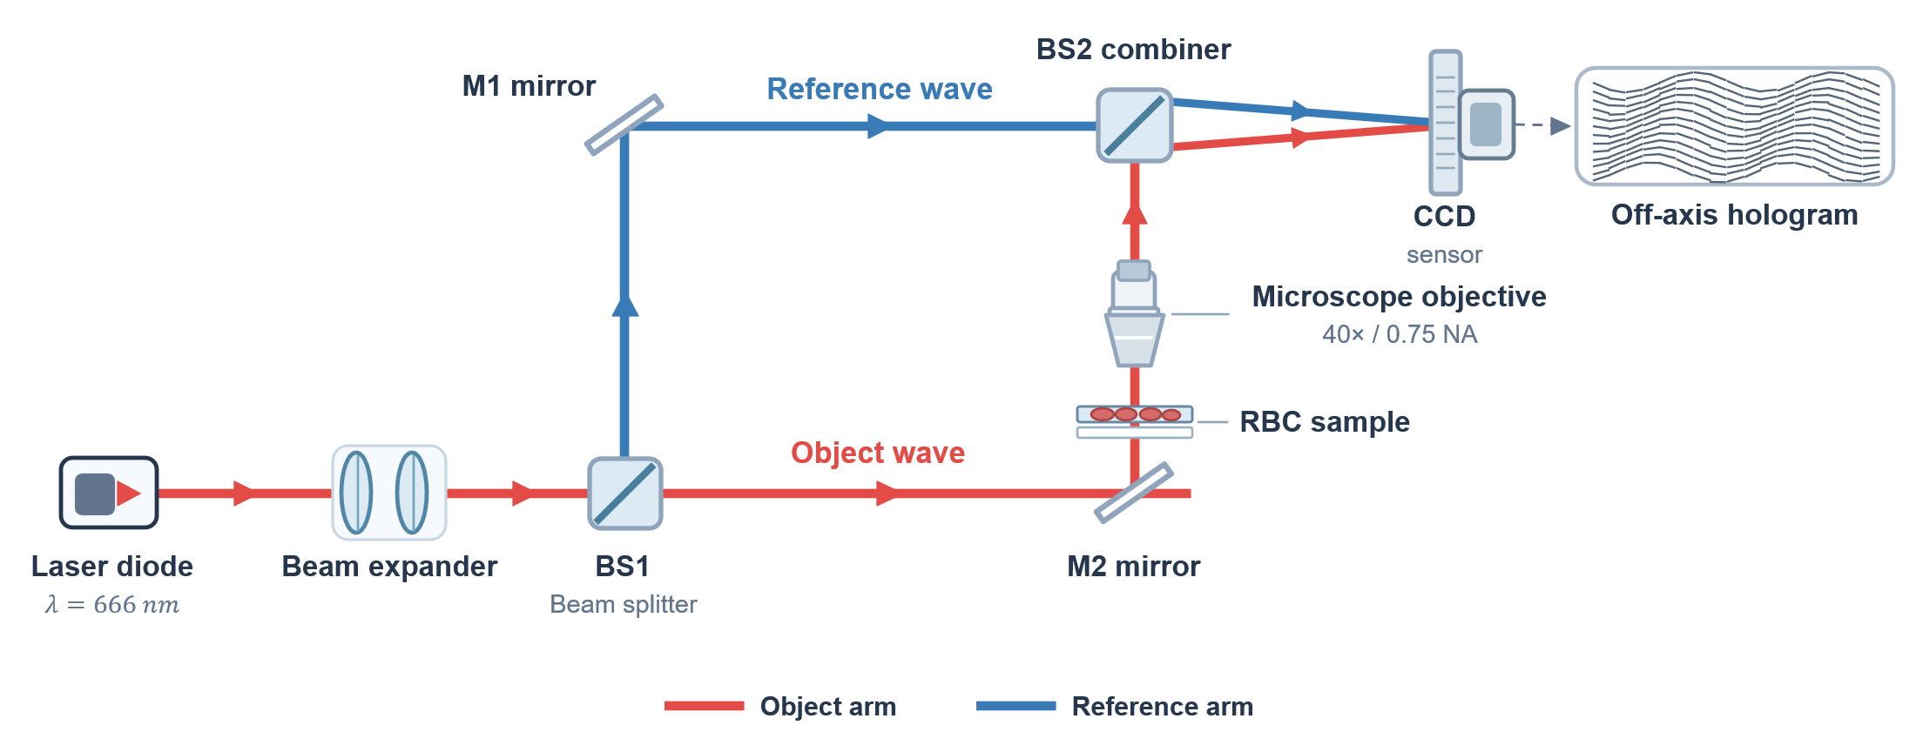
Fig. 2 Schematic of the off-axis transmission Mach-Zehnder DHM setup used to acquire the RBC dataset. BS1/BS2, beam splitters; M1/M2, mirrors. Schematic redrawn for this manuscript; not to scale.
  - Training Configuration
All networks were optimized using the AdamW optimizer with a cosine annealing learning-rate schedule. Mixed-precision (FP16) training was employed to reduce memory consumption and improve computational efficiency. A major challenge in longitudinal RBC morphology analysis is the substantial class imbalance caused by the relatively low prevalence of certain morphological classes, particularly at specific storage stages. To mitigate this imbalance, a two-level strategy was employed. At the data-loading level, a WeightedRandomSampler dynamically assigned sampling probabilities according to the inverse frequency of the constituent classes, thereby increasing the exposure of underrepresented RBC morphologies during training. At the optimization level, the class-weighted Multi-Class Dice Loss described in Section 2.5.1 was applied. LoRA rank-sweep experiments were conducted using $r∈\{2,4,8,16,32\}$ to determine an appropriate balance between adaptation capacity, segmentation performance, and parameter efficiency. All configurations reported in this study—including the LoRA rank sweep, comparison with full fine-tuning, and physics-aware loss ablation—were trained using an identical optimization schedule and evaluated on the same validation split to ensure a controlled comparison.
  - Evaluation Metrics
The proposed framework was evaluated using three complementary categories of metrics: segmentation performance, quantitative phase preservation, and computational efficiency.
    - Segmentation Performance
Spatial agreement between predicted and ground-truth masks was evaluated using the Dice coefficient and Intersection-over-Union (IoU). Both metrics were macro-averaged exclusively over the four foreground RBC morphology classes. A morphology class that was not predicted by the model was assigned a score of zero rather than being excluded from the average. This evaluation strategy prevents the dominant background class from inflating the aggregate performance and enables failures in minority morphology classes to be directly reflected in the reported scores. To additionally evaluate instance-level separation in densely distributed cellular regions, the Aggregated Jaccard Index (AJI) was calculated.
    - Quantitative Phase Preservation
The physical fidelity of the predicted measurement boundaries was evaluated using the IPE. This metric quantifies the relative difference between the phase-integrated optical quantities obtained from the predicted and ground-truth cellular regions, consistent with the integrated-phase definition in Eq. (9). For a predicted integrated phase S_{pred} and the corresponding ground-truth value S_{GT}, IPE is defined as
$IPE(\%)=\frac{\left|S_{pred}-S_{GT}\right|}{\left|S_{GT}\right|+ϵ}100.$ (11)
IPE was evaluated both globally and for individual RBC morphology classes. For each image, $S_{pred}$ and $S_{GT}$ are accumulated by summing the phase over all pixels in the relevant foreground region (the full foreground for the global formulation, or the corresponding class mask for class-specific IPE), and Eq. (11) is evaluated per image; the reported global IPE is the mean of these per-image values, and class-specific IPE is the mean over the images that contain that class. Because Eq. (11) operates on $\left|S_{pred}-S_{GT}\right|$, IPE is an absolute (unsigned) error, so over- and under-estimation in different images cannot cancel in the reported mean; within one image, however, the phase is summed over all cells before the absolute value is taken, which is why the per-cell IPE is also reported below. A morphology class with zero detections yields $S_{pred}=0$ for that class, which is not excluded but is instead reflected directly in Eq. (11) as an IPE approaching 100%, consistent with the complete-detection-failure cases reported in Section 4.4. In addition to the global formulation in Eq. (11), a per-cell IPE was computed by matching each ground-truth cell (projected area 15 to 200 µm²) one-to-one with a predicted cell (IoU ≥ 0.5) and evaluating the relative phase-integral error for that cell individually, using phase after subtraction of a least-squares background plane; unmatched cells were excluded from this per-cell statistic. For the selected EdgeSAM configuration (r = 8), the per-cell median IPE was 3.04% (90th percentile 11.57%), with 73.7% of ground-truth cells successfully matched to a predicted cell. A lower IPE indicates that the predicted segmentation boundary more accurately preserves the phase-integrated optical information associated with the cell and therefore provides a more reliable measurement domain for subsequent optical-mass and dry-mass analysis. Boundary accuracy was additionally evaluated using the boundary F1-score with a 2-pixel tolerance. The globally pooled boundary F1-score quantifies the spatial agreement between predicted and annotated cellular contours and complements IPE by evaluating geometric boundary fidelity independently of the integrated phase quantity. Together, boundary F1 and IPE provide complementary measures of geometric boundary accuracy and optical-mass preservation, respectively.
    - Computational Efficiency
Computational efficiency was characterized using median inference latency, tail latency, throughput in frames per second (FPS), trainable parameter count, and peak VRAM allocation. These metrics were used to quantify the computational requirements of each lightweight architecture and to assess its potential suitability for future implementation in resource-constrained holographic imaging systems.
  - Computational Benchmarking Protocol
Computational benchmarking was performed on an NVIDIA RTX A5000 GPU to characterize the relative inference efficiency of the evaluated lightweight architectures. Profiling was conducted independently of the primary training procedure to avoid interference from training-related computational overhead. For stable latency measurement, each model underwent 50 unrecorded warm-up iterations followed by 500 synchronized forward passes. Inference performance was evaluated under FP32 and FP16 precision using both native PyTorch execution and, where supported, static-graph execution through ONNX Runtime (ORT) with the CUDA Execution Provider.
The purpose of this experiment was to establish the relative computational efficiency of the candidate architectures under a controlled GPU environment rather than to demonstrate actual embedded deployment. The resulting latency, throughput, memory, and parameter measurements therefore characterize the computational requirements of the proposed framework and its potential for future implementation on resource-constrained hardware. MobileSAM was excluded from ONNX benchmarking because structural operations within its cross-attention mask decoder were not fully supported by the ORT CUDA Execution Provider, resulting in partial CPU fallback. Native PyTorch inference was therefore used for MobileSAM when comparing computational performance.
  - Ablation Studies
Three groups of ablation experiments were designed to systematically evaluate the contribution of the major components of the proposed framework. First, a LoRA rank-sweep analysis was conducted using $r∈\{2,4,8,16,32\}$ to characterize the relationship among adaptation capacity, segmentation accuracy, quantitative phase preservation, and parameter efficiency. This experiment was used to identify an appropriate LoRA configuration for each lightweight architecture. The results are given in the Supplementary Information (Section S-I). Second, LoRA adaptation at the selected rank was directly compared with full fine-tuning of the corresponding network. The comparison was performed for all three architectures under the same training objective, optimization schedule, and validation split. This experiment evaluates whether parameter-efficient adaptation can preserve segmentation performance and minority morphology classes while substantially reducing the number of trainable parameters. Third, a component-wise ablation of the Physics-Aware Phase Consistency Loss was performed across all three lightweight architectures. Starting from the Multi-Class Dice-only baseline, the PMC, BGA, and IPP terms were progressively introduced. The resulting models were compared using segmentation metrics, boundary F1-score, and IPE. This ablation was designed to determine the individual and complementary contributions of the three physical constraints. In particular, it evaluates whether the proposed physics-aware objective improves not only geometric segmentation accuracy but also the preservation of the phase-integrated optical information required for reliable optical-mass and dry-mass analysis.
  - Statistical Analysis
Statistical analyses were performed to evaluate storage-associated changes in RBC morphology and phase-derived quantitative measurements. Because cells segmented from the same QPI share common acquisition conditions, individual cells were not treated as statistically independent observations. The image was therefore used as the unit of analysis, with each image represented by the median of its detected cells. Cell-level distributions were reported as descriptive summaries. Monotonic associations between quantitative measurements and storage duration were evaluated using Spearman rank correlation. Differences between the early discocyte-dominated storage period and the terminal storage period were evaluated using a two-sided Mann-Whitney test. For phase-integrated quantities that co-vary with projected area, partial Spearman correlation controlling for area was used to determine whether an independent association with storage duration remained. Agreement between measurements derived from predicted and manually annotated boundaries was assessed using Pearson correlation of the per-image medians, Lin’s concordance correlation coefficient (CCC) [45], the median absolute relative error (MdARE), and Bland-Altman bias [46]. MdARE was computed as the median, across images, of the absolute difference between predicted-mask and annotation-mask dry mass divided by the annotation-mask dry mass, using per-image median dry-mass values. Bland-Altman bias is the mean predicted-minus-annotation difference in pg.
- Results
The proposed lightweight, physics-aware segmentation framework was evaluated using the DHM dataset to assess three principal aspects: multi-class segmentation performance, preservation of phase-integrated optical information for quantitative cell analysis, and computational efficiency. Particular emphasis was placed on determining whether accurate segmentation boundaries could simultaneously support reliable optical-mass-related measurements across different RBC morphologies.
  - Segmentation Accuracy Comparison
Three lightweight architectures—EdgeSAM, MobileSAM, and MobileNet-UNet—were first evaluated to identify a suitable model for quantitative holographic cell segmentation. LoRA was applied to adapt the pretrained architectures to the distinct characteristics of single-channel QPI phase maps. The models were evaluated in terms of multi-class segmentation accuracy, instance separation, boundary fidelity, and trainable parameter efficiency. As summarized in Table 1, the three architectures exhibited substantially different performance characteristics, indicating that no single aggregate segmentation metric was sufficient for model selection. MobileSAM achieved the highest mean Dice score (0.812) but showed relatively poor instance separation and boundary quality, with an AJI of 0.249 and Boundary F1 of 0.644. Qualitative inspection further showed that adjacent cells in densely populated regions were frequently merged into single components.
TABLE 1 Segmentation performance at the selected LoRA rank (r = 8). Best value per column is shown in bold. Mean Dice is macro-averaged over the four foreground morphology classes. Dice_{echi} and Dice_{stom} denote per-class Dice scores for echinocytes and stomatocytes, respectively; 0.000 indicates complete class-detection failure, for which aggregate boundary metrics require cautious interpretation.
Architecture | Rank | Mean Dice $↑$ | AJI $↑$ | Boundary F1 $↑$ | Dice$​_{\text{echi}}↑$ | Dice$​_{\text{stom}}↑$ | Params $↓$
MobileNet-UNet | 8 | 0.417 | 0.634 | 0.971 | 0.000 | 0.000 | 5.58M
MobileSAM | 8 | 0.812 | 0.249 | 0.644 | 0.852 | 0.710 | 0.67M
EdgeSAM | 8 | 0.727 | 0.484 | 0.952 | 0.776 | 0.536 | 0.53M

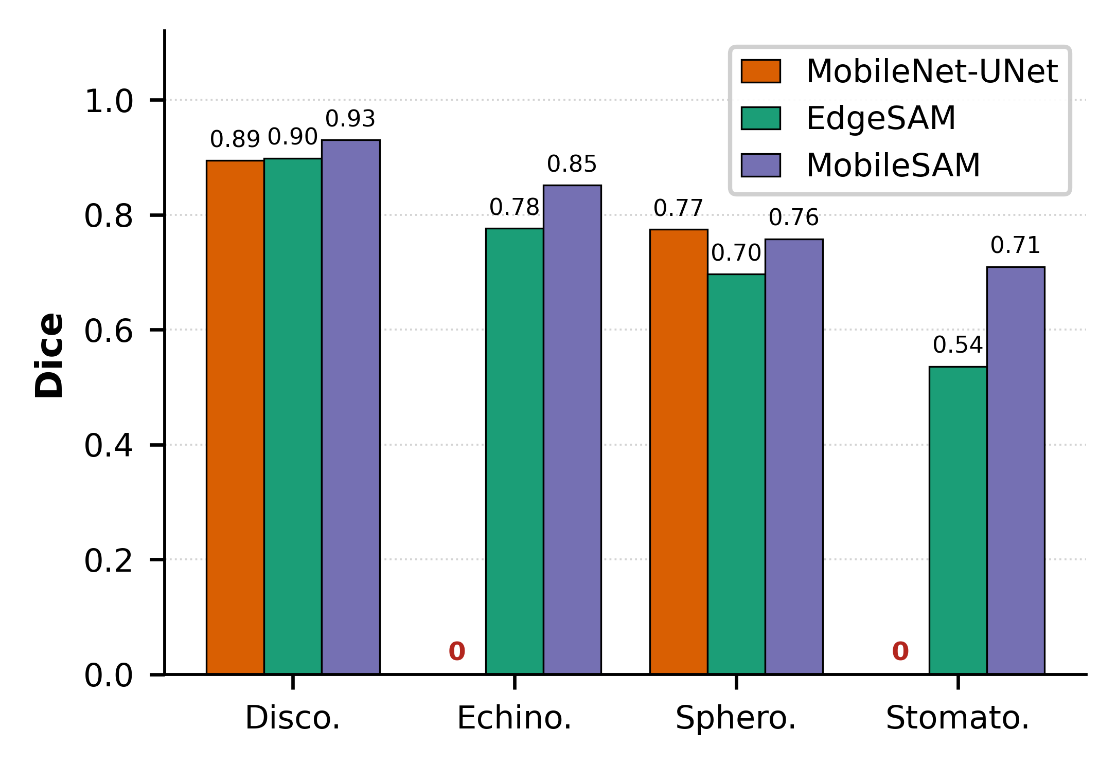
Fig. 3 Per-class Dice scores of MobileNet-UNet, MobileSAM, and EdgeSAM at the selected LoRA rank (r = 8). Zero-height bars indicate complete failure to detect the corresponding morphology class.
The per-class Dice scores shown in Fig. 3 further reveal substantial differences in morphology-specific segmentation performance. MobileNet-UNet completely failed to detect echinocytes and stomatocytes, yielding a Dice score of zero for both classes, despite its nominally high Boundary F1 (0.971) and AJI (0.634). In contrast, MobileSAM and EdgeSAM maintained non-zero Dice scores across all four RBC morphologies. These results demonstrate that aggregate boundary and instance metrics alone can obscure complete segmentation failure for minority morphology classes. EdgeSAM provided the most balanced performance across the evaluated criteria. It achieved a mean Dice of 0.727, AJI of 0.484, and Boundary F1 of 0.952 while maintaining non-zero segmentation performance for all four RBC morphologies. In particular, as illustrated in Fig. 3, EdgeSAM achieved Dice scores of 0.776 and 0.536 for echinocytes and stomatocytes, respectively. These results are particularly relevant because both classes are less represented in the dataset and are therefore more susceptible to degradation during model adaptation. For quantitative holographic cell analysis, balanced segmentation performance is important because the predicted cellular boundary defines the spatial measurement domain over which the quantitative phase is subsequently integrated. Reliable quantitative analysis therefore requires not only high region overlap but also complete morphology coverage, accurate boundary localization, and adequate separation of individual cells. A model that completely misses a particular morphology or merges adjacent cells cannot provide reliable per-cell phase-integrated measurements, even when its aggregate segmentation metrics appear favorable.
Among the evaluated architectures, EdgeSAM was the only model that simultaneously maintained non-degenerate segmentation across all four RBC morphologies, high boundary fidelity, and adequate instance separation while requiring only 0.53 M trainable parameters. MobileSAM required substantially more trainable parameters and showed limited instance separation, whereas MobileNet-UNet, despite its high nominal Boundary F1 and AJI, failed to identify two morphology classes. Visual comparisons further corroborated these quantitative findings. MobileNet-UNet produced empty prediction masks for several minority-class cells, whereas MobileSAM frequently merged neighboring cells into single segmented regions. In contrast, EdgeSAM provided individualized cellular contours across the evaluated RBC morphologies, including the more complex boundaries associated with echinocytic cells.
The aggregate comparison across criteria is shown in Fig. S-2; because it does not encode morphology-class coverage, the high Boundary F1 and AJI of MobileNet-UNet must be read together with its complete failure on echinocytes and stomatocytes (Fig. 3). MobileSAM provided the highest mean Dice but was limited by poor instance separation and a substantially larger trainable parameter count. EdgeSAM, in contrast, provided the most balanced overall profile across the criteria required for quantitative holographic cell analysis. Based on this combined evaluation, EdgeSAM was selected as the primary architecture for subsequent quantitative phase preservation, physics-aware loss, and computational efficiency analyses. Its ability to maintain segmentation across all RBC morphologies while providing accurate cellular boundaries and adequate instance separation makes it particularly suitable for the proposed framework, in which segmentation masks serve as measurement domains for preserving phase-integrated optical information and supporting subsequent optical-mass and dry-mass analysis.
LoRA rank was selected for EdgeSAM from a sweep over r = 2, 4, 8, 16, and 32. Rank 8 gave the best balance of segmentation accuracy, instance separation, IPE, and trainable parameters (0.53 M), and was used in all subsequent analyses (Table S-1, Fig. S-1).
  - Parameter-Efficient Adaptation versus Full Fine-Tuning
To evaluate the effectiveness of parameter-efficient adaptation, LoRA at the selected rank (r = 8) was compared with full fine-tuning for all three architectures under the same training and evaluation conditions. As summarized in Table 2, LoRA provided more stable adaptation, particularly for the minority RBC morphology classes. For EdgeSAM, full fine-tuning reduced the mean Dice from 0.727 to 0.557 and caused complete collapse of the echinocyte class (Dice: 0.776 to 0.000), while increasing the IPE from 3.63% to 5.08%. Similar minority-class degradation was observed for MobileSAM, whereas full fine-tuning did not resolve the class-collapse problem of MobileNet-UNet.
Fig. 4 further illustrates the advantage of LoRA over full fine-tuning in preserving morphology-specific segmentation performance. Despite using substantially fewer trainable parameters, LoRA maintained more balanced performance across RBC morphologies, whereas unrestricted full fine-tuning resulted in severe degradation or complete loss of minority classes for EdgeSAM and MobileSAM. These results indicate that increasing the number of trainable parameters does not necessarily improve adaptation to QPI phase images. Instead, constraining adaptation to low-rank parameter updates helps retain useful pretrained representations while providing sufficient flexibility for the QPI domain. Among the evaluated configurations, LoRA-adapted EdgeSAM provided the most favorable balance of multi-class segmentation performance, integrated-phase preservation, and parameter efficiency.
TABLE 2 Comparison of LoRA (r = 8) and full fine-tuning across the three architectures. Best result per architecture is shown in bold. Dice_{echi} and Dice_{stom} denote per-class Dice scores for echinocytes and stomatocytes, respectively, and IPE denotes the global Integrated-Phase Error. All models were evaluated on the same validation split using the full physics-aware objective.
Architecture | Method | Trainable Params | Mean Dice $↑$ | BF1 $↑$ | AJI $↑$ | IPE (%) $↓$ | Dice$​_{\text{echi}}↑$ | Dice$​_{\text{stom}}↑$
EdgeSAM | LoRA ($r=8$) | 0.53M (8.90%) | 0.727 | 0.952 | 0.484 | 3.63 | 0.776 | 0.536
EdgeSAM | Full Fine-Tune | 5.69M (100%) | 0.557 | 0.931 | 0.431 | 5.08 | 0.000 | 0.625
MobileSAM | LoRA ($r=8$) | 0.67M (10.0%) | 0.812 | 0.644 | 0.249 | 2.57 | 0.852 | 0.710
MobileSAM | Full Fine-Tune | 6.66M (100%) | 0.419 | 0.665 | 0.280 | 2.76 | 0.000 | 0.000
MobileNet-UNet | LoRA ($r=8$) | 5.58M (71.8%) | 0.417 | 0.971 | 0.634 | 2.60 | 0.000 | 0.000
MobileNet-UNet | Full Fine-Tune | 7.62M (100%) | 0.420 | 0.969 | 0.705 | 3.56 | 0.000 | 0.000

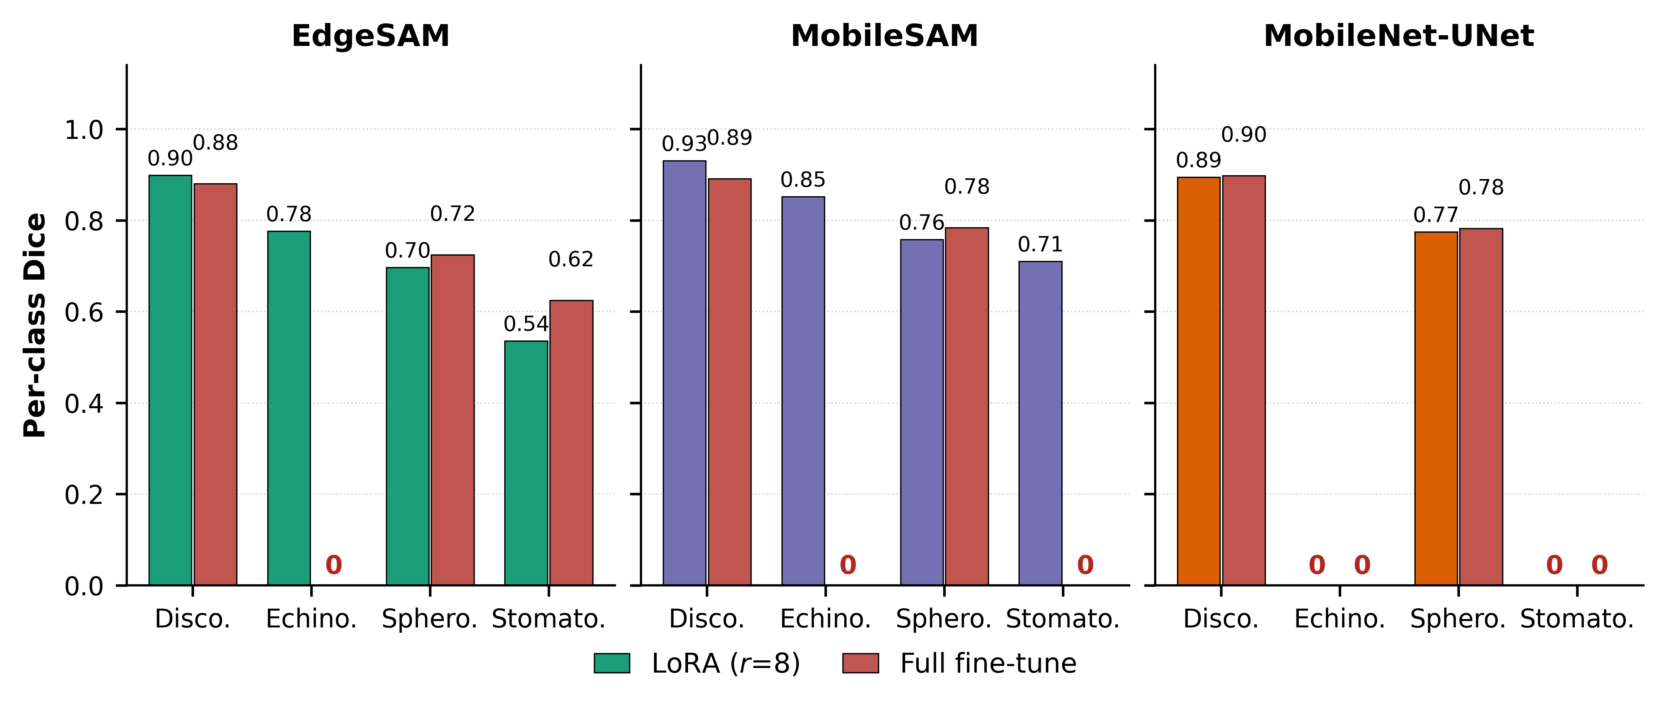
Fig. 4 Per-class Dice scores comparing LoRA (r = 8) with full fine-tuning across the three lightweight architectures. Zero-height bars indicate complete failure to detect the corresponding morphology class.
  - Physics-Aware Loss Ablation
To evaluate the contribution of each physics-aware constraint, a component-wise ablation was performed across all three architectures at r = 8. Four configurations were compared: (i) Multi-Class Dice loss alone, (ii) Dice with PMC, (iii) Dice with PMC and BGA, and (iv) the full objective incorporating IPP. Table 3 summarizes the global segmentation and integrated-phase metrics, while Table 4 provides the corresponding morphology-specific results for EdgeSAM. Note that the EdgeSAM r = 8 values in Table 3 (Dice 0.740, IPE 3.04%) differ slightly from the corresponding r = 8 entry in Table S-1 (Dice 0.727, IPE 3.63%); both use identical nominal hyperparameters but were trained as independent runs for the rank-sweep and loss-ablation experiments respectively, and the small gap reflects ordinary run-to-run training variation rather than a discrepancy in the underlying pipeline. A larger gap is seen for MobileSAM (Tables 1 and 2: Dice 0.812, IPE 2.57%; Table 3, full objective: Dice 0.607, IPE 7.25%). Although the two runs used identical settings, the loss-ablation full-objective run did not converge: its validation Dice fell from 0.607 at epoch 1 to below 0.42 and remained there, whereas the Table 1 run improved steadily to 0.81. The Table 3 row therefore reflects the epoch-1 checkpoint of a non-converged run and is not a reliable estimate of the effect of IPP on MobileSAM.
TABLE 3 Component-wise ablation of the Physics-Aware Phase Consistency Loss at the selected LoRA rank (r = 8). Best value per column within each architecture is shown in bold. Each row progressively adds a physics-aware constraint, and IPE denotes the global Integrated-Phase Error (%, lower is better). The ablation runs were trained independently; therefore, comparisons are made within this table to account for run-to-run variation.
Architecture | Loss Configuration | Dice $↑$ | IoU $↑$ | BF1 $↑$ | AJI $↑$ | IPE (%) $↓$
EdgeSAM | $L_{\text{Dice}}$ only | 0.757 | 0.621 | 0.938 | 0.525 | 5.22
EdgeSAM | $$+ L_{\text{PMC}}$$ | 0.608 | 0.511 | 0.386 | 0.339 | 47.20
EdgeSAM | $$+ L_{\text{PMC}}+L_{\text{BGA}}$$ | 0.763 | 0.627 | 0.929 | 0.421 | 6.13
EdgeSAM | Full $L$ ($+ L_{\text{IPP}}$) | 0.740 | 0.601 | 0.953 | 0.377 | 3.04
MobileNet-UNet | $L_{\text{Dice}}$ only | 0.425 | 0.374 | 0.913 | 0.633 | 15.52
MobileNet-UNet | $$+ L_{\text{PMC}}$$ | 0.423 | 0.370 | 0.909 | 0.622 | 16.52
MobileNet-UNet | $$+ L_{\text{PMC}}+L_{\text{BGA}}$$ | 0.423 | 0.371 | 0.916 | 0.646 | 16.05
MobileNet-UNet | Full $L$ ($+ L_{\text{IPP}}$) | 0.419 | 0.363 | 0.970 | 0.675 | 3.01
MobileSAM | $L_{\text{Dice}}$ only | 0.813 | 0.695 | 0.665 | 0.235 | 2.46
MobileSAM | $$+ L_{\text{PMC}}$$ | 0.588 | 0.492 | 0.543 | 0.205 | 10.05
MobileSAM | $$+ L_{\text{PMC}}+L_{\text{BGA}}$$ | 0.804 | 0.683 | 0.664 | 0.251 | 2.37
MobileSAM | Full $L$ ($+ L_{\text{IPP}}$) | 0.607 | 0.464 | 0.465 | 0.246 | 7.25

TABLE 4 Per-class IPE and Dice scores for different loss configurations using EdgeSAM (r = 8). Best IPE and Dice per morphology are shown in bold. The extreme stomatocyte IPE with PMC alone reflects severe class-prediction failure with substantial phase-integral overestimation (Dice = 0.018); global IPE in Table 3 provides the primary measure of integrated-phase preservation.
Loss Config. | Disco. | Echi. | Sphero. | Stomato.
IPE (%) ↓
$L_{\text{Dice}}$ only | 8.14 | 27.09 | 26.91 | 56.13
$$+L_{\text{PMC}}$$ | 8.21 | 32.27 | 31.94 | 1073.58
$$+L_{\text{PMC}}+L_{\text{BGA}}$$ | 8.08 | 36.73 | 31.53 | 50.04
Full $L$ | 7.01 | 37.66 | 29.51 | 59.73
Dice ↑
$L_{\text{Dice}}$ only | 0.903 | 0.793 | 0.732 | 0.598
$$+L_{\text{PMC}}$$ | 0.894 | 0.787 | 0.732 | 0.018
$$+L_{\text{PMC}}+L_{\text{BGA}}$$ | 0.903 | 0.776 | 0.731 | 0.643
Full $L$ | 0.900 | 0.784 | 0.687 | 0.587
For EdgeSAM, the Dice-only baseline achieved a mean Dice of 0.757, Boundary F1 of 0.938, and global IPE of 5.22%. Adding PMC alone substantially degraded both boundary fidelity and integrated-phase preservation, whereas the addition of BGA restored the mean Dice to 0.763 and Boundary F1 to 0.929. As illustrated in Fig. S-4, BGA promotes alignment of predicted contours with spatial phase gradients, providing a physical cue for cellular boundary localization. Table 4 further shows that PMC alone severely degraded stomatocyte segmentation, whereas the addition of BGA restored its Dice score from 0.018 to 0.643.
The complete objective incorporating IPP achieved the lowest global IPE (3.04%) and the highest Boundary F1 (0.953) for EdgeSAM, as directly compared in Fig. 5. A stronger improvement in integrated-phase preservation was observed for MobileNet-UNet, where IPE decreased from 15.52% with Dice alone to 3.01% with the full objective, while Boundary F1 increased from 0.913 to 0.970. These results demonstrate that explicit integrated-phase preservation provides quantitative information not captured by geometric overlap alone. For MobileSAM, the Dice+PMC+BGA configuration achieved a lower IPE (2.37%) than the full objective (7.25%); however, the full-objective MobileSAM run did not converge (best checkpoint at epoch 1) so this row does not establish an architecture-dependent effect of IPP. To assess whether IPP introduces a phase-dependent bias, cells were stratified into phase quartiles and the false-negative rate within ground-truth cells was compared with and without IPP. Misses concentrated in the lowest-phase quartile for all models (18–33%). For EdgeSAM and MobileNet-UNet, adding IPP did not increase this low-phase bias and reduced it slightly (33.3% to 28.7% and 27.2% to 25.0%, respectively). For MobileSAM, the full-objective run showed a higher lowest-quartile miss rate (18.3% to approximately 30%), but this run did not converge, so no conclusion about IPP is drawn for this architecture. To evaluate robustness to background phase variation, synthetic constant offsets and low-order aberration-like fields (tilt, defocus-like, and astigmatism-like distortions) of increasing magnitude were added to held-out phase maps and re-evaluated. Segmentation accuracy was essentially unaffected by constant offsets (EdgeSAM Dice unchanged, as expected because each input image is standardized before inference, which removes a constant offset) and only modestly reduced under the largest tilt, defocus-like, and astigmatism-like distortions tested (EdgeSAM Dice 0.739 to 0.720, 0.735, and 0.706, respectively). As expected, the uncorrected IPE increased with offset magnitude (EdgeSAM 3.55% to 3.92% at the largest offset tested; the unperturbed baseline of 3.55% differs from the 3.04% in Table 3 because this analysis evaluates at the native 768 × 768 resolution), consistent with IPE being computed directly on the raw, background-uncorrected phase. Overall, the ablation results demonstrate complementary roles of the three physics-aware components: PMC incorporates phase-based foreground information, BGA improves boundary localization using phase gradients, and IPP directly constrains preservation of the integrated quantitative phase within the predicted measurement domain.
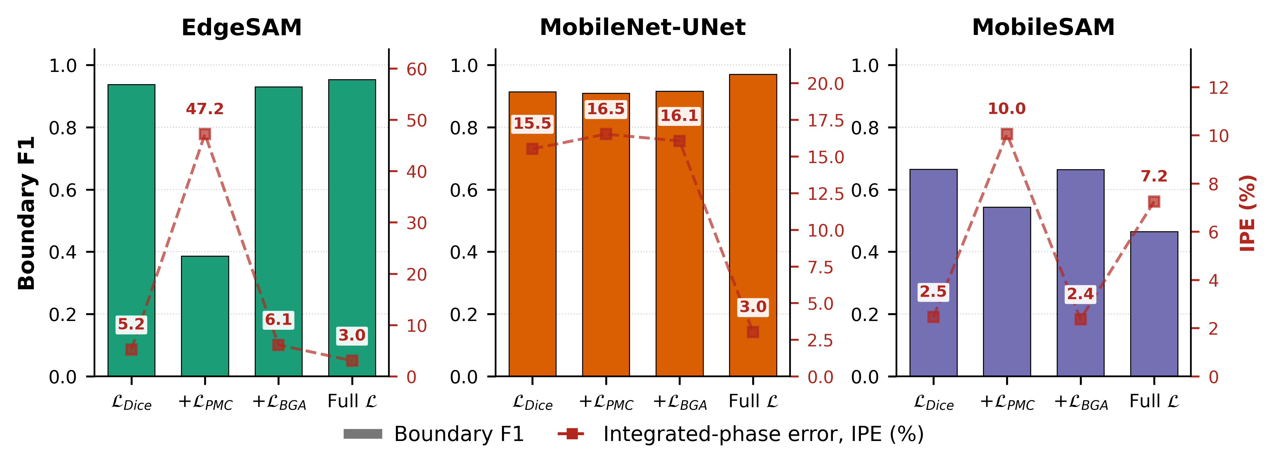
Fig. 5 Component-wise loss ablation at the selected LoRA rank (r = 8), comparing boundary fidelity and integrated-phase preservation. Bars indicate Boundary F1 (left axis), and the dashed line indicates global Integrated-Phase Error (IPE; right axis).
  - Integrated-Phase and Optical-Mass Preservation Analysis
The preservation of phase-integrated optical information was evaluated using the IPE. As summarized in Table 5, EdgeSAM achieved a global IPE of 3.63%, while MobileSAM and MobileNet-UNet achieved 2.57% and 2.60%, respectively. However, global IPE alone does not fully characterize the reliability of per-cell quantitative measurements. MobileNet-UNet completely failed to detect echinocytes and stomatocytes, resulting in 100% class-specific IPE for both morphologies. MobileSAM achieved the lowest global IPE but exhibited poor instance separation (AJI = 0.249), frequently merging adjacent cells and thereby limiting reliable per-cell measurements. In contrast, EdgeSAM maintained non-degenerate segmentation across all four RBC morphologies while providing adequate instance separation and a low global IPE. These results demonstrate that reliable optical-mass preservation requires integrated-phase fidelity together with accurate morphology coverage and individual-cell separation. Among the evaluated architectures, EdgeSAM therefore provided the most balanced measurement domain for subsequent phase-derived quantitative analysis.
TABLE 5 Integrated-phase preservation analysis at the selected LoRA rank (r = 8). Best value per column is shown in bold. Global and class-specific IPEs are reported for each architecture. Low global IPE alone does not ensure reliable single-cell quantitative analysis when morphology detection or instance separation fails.
Architecture | Rank ($r$) | Global IPE (%) $↓$ | Class-Specific IPE (%) ↓ |  |  |  | AJI $↑$
Architecture | Rank ($r$) | Global IPE (%) $↓$ | Discocyte | Echinocyte | Spherocyte | Stomatocyte | AJI $↑$
MobileNet-UNet | 8 | 2.60 | 61.2 | 100.0 | 27.6 | 100.0 | 0.634
MobileSAM | 8 | 2.57 | 6.8 | 33.0 | 33.7 | 47.9 | 0.249
EdgeSAM | 8 | 3.63 | 7.3 | 35.2 | 27.2 | 64.1 | 0.484
  - Computational Efficiency Analysis
Computational efficiency was evaluated on an NVIDIA RTX A5000 using native PyTorch and, where supported, ORT under FP32 and FP16 precision. As summarized in Table 6, EdgeSAM achieved substantial acceleration with ORT, reducing the median latency from 13.36 ms in PyTorch FP32 to 4.33 ms in ONNX FP16 and increasing throughput from 74.82 to 228.33 FPS, while requiring only 16.4 MB of peak allocated VRAM. MobileNet-UNet achieved the highest throughput (376.10 FPS with ONNX FP16) but failed to detect two RBC morphology classes, whereas MobileSAM exhibited higher computational requirements and could not be reliably accelerated using ORT because of unsupported decoder operations. Considering segmentation reliability, integrated-phase preservation, and computational efficiency together, EdgeSAM provided the most balanced overall performance among the evaluated architectures. These measurements characterize GPU-based computational efficiency rather than actual embedded-device deployment. Nevertheless, the low latency and memory requirements of EdgeSAM support its potential for future implementation in resource-constrained holographic imaging systems. The accuracy-throughput trade-off among the three architectures is shown in Fig. S-3.
TABLE 6 Computational benchmarking on an NVIDIA RTX A5000 at the selected LoRA rank (r = 8). Best value per column is shown in bold. Latency is reported as median (p₅₀) and tail (p₉₉) latency, and peak VRAM denotes the peak allocated device memory. MobileSAM is reported under native PyTorch only because its cross-attention mask decoder is not fully supported by the ORT CUDA Execution Provider.
Model | Runtime | Precision | $p_{50}$ (ms) $↓$ | $p_{99}$ (ms) $↓$ | FPS $↑$ | Peak VRAM (MB) $↓$
EdgeSAM | PyTorch | FP32 | 13.36 | 13.89 | 74.82 | 177.9
EdgeSAM | ONNX | FP32 | 3.99 | 4.21 | 248.87 | 24.6
EdgeSAM | PyTorch | FP16 | 15.87 | 16.96 | 62.64 | 157.4
EdgeSAM | ONNX | FP16 | 4.33 | 4.70 | 228.33 | 16.4
MobileNet-UNet | PyTorch | FP32 | 7.42 | 9.07 | 132.69 | 186.0
MobileNet-UNet | ONNX | FP32 | 2.75 | 4.12 | 359.61 | 24.6
MobileNet-UNet | PyTorch | FP16 | 6.62 | 8.22 | 148.87 | 161.2
MobileNet-UNet | ONNX | FP16 | 2.62 | 4.15 | 376.10 | 16.4
MobileSAM | PyTorch | FP32 | 19.07 | 19.30 | 52.33 | 528.3
MobileSAM | PyTorch | FP16 | 17.33 | 19.55 | 57.18 | 270.7

  - Visualization of Segmentation and Morphology Classification Results
Qualitative segmentation results further support the quantitative evaluation. As shown in Fig. 6, the LoRA-adapted EdgeSAM successfully delineated individual RBCs across the four morphology classes, including discocytes, echinocytes, spherocytes, and stomatocytes. The predicted contours generally followed the cellular structures observed in the corresponding quantitative phase maps, including the more complex boundaries of echinocytic cells. MobileNet-UNet recovered the discocytes and spherocytes but missed echinocytes and stomatocytes, consistent with the per-class results in Section 4.1. Importantly, the predicted masks provided individualized cellular regions rather than merged foreground regions, supporting their use as measurement domains for subsequent phase-integrated quantitative analysis. These qualitative results are consistent with the morphology coverage, boundary fidelity, and instance-separation performance reported in Sections 4.1 and 4.4.
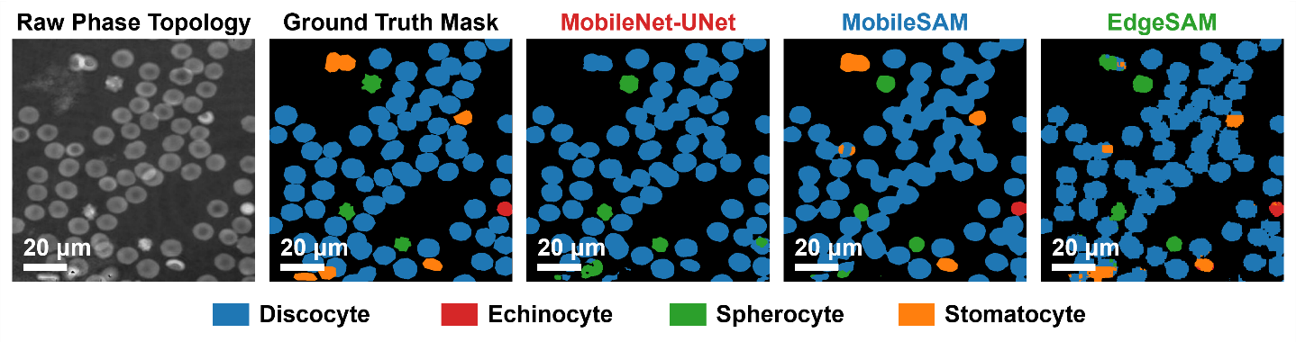
Fig. 6 Qualitative segmentation results of LoRA-adapted MobileNet-UNet, MobileSAM, and EdgeSAM (r = 8) across different RBC morphologies, including discocytes, echinocytes, spherocytes, and stomatocytes.
  - Storage-Induced Morphology Degradation
To evaluate the applicability of the proposed framework to quantitative biological analysis, storage-induced changes in RBC morphology and phase-derived biophysical properties were examined over the 47-day storage period. Geometric and phase-derived quantities were extracted from individual RBCs using the segmentation masks generated by the selected LoRA-adapted EdgeSAM (r = 8). Each storage time point consisted of six independent validation patches; therefore, the analysis represents cross-sectional population changes rather than longitudinal tracking of the same individual cells.
The predicted RBC morphology distributions showed systematic changes over the 47-day storage period. As shown in Fig. 7, discocytes predominated at the initial storage time point (day 0) and gradually decreased with storage duration, whereas echinocytes and spherocytes became increasingly prevalent at later time points. Stomatocytes remained a substantial minority class, rising from 10% at day 0 to a maximum of 26% at day 19 and accounting for 15% at day 47 (Table 7).
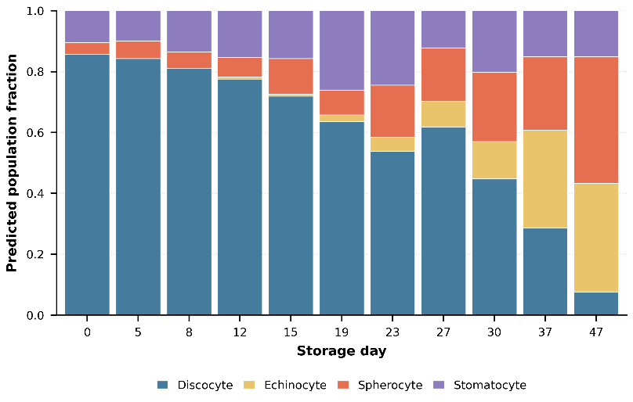
Fig. 7 Predicted RBC morphology composition over the 47-day storage period, pooled across all cells detected at each time point using LoRA-adapted EdgeSAM (r = 8).

Representative quantitative phase images in Fig. S-5 further illustrate these storage-associated morphological changes, showing a transition from predominantly biconcave discocytes at the initial storage time point to increased occurrence of altered RBC morphologies at later storage stages. The agreement between the predicted morphology distributions and the corresponding QPI appearances demonstrates that the proposed framework can quantify population-level morphological changes associated with prolonged RBC storage.
  - Quantitative Phase-Derived Cellular Analysis Across Storage
Quantitative cellular measurements were extracted from the EdgeSAM-predicted masks to evaluate storage-associated changes in RBC morphology and phase-derived biophysical properties. As summarized in Table 7, the projected cell area did not decrease monotonically over the storage period; it instead increased from 63.1 µm² at day 0 to a peak of 83.6 µm² at day 15, before declining to 43.4 µm² by day 47 (Spearman ρ=−0.67, p<0.001, overall). The day-15 peak coincides with the time point containing the largest number of multi-cell clusters in the annotated data, which may inflate the apparent per-component area at that time point. Circularity also changed over the storage period, consistent with the population-level morphological changes observed in Fig. 7 and Fig. S-5. Phase-derived dry-mass estimates likewise fluctuated rather than remaining stable, showing a significant overall decline with storage duration (Spearman ρ=−0.40, p=0.0009); a partial correlation controlling for projected area was substantially weaker and not statistically significant (partial ρ=−0.15, p=0.23), indicating that the dry-mass decline is largely, though not entirely, explained by the concurrent change in projected area. Fig. 8 shows the relationship between projected area and dry mass, indicating that the substantial change in the two-dimensional cellular footprint was not accompanied by a proportional change in phase-derived dry mass. These results demonstrate that projected morphological changes and phase-derived cellular mass provide complementary quantitative information on storage-associated changes in RBC populations.
To evaluate the reliability of the predicted segmentation masks as quantitative measurement domains, dry-mass estimates obtained from EdgeSAM-predicted masks were compared with those derived from annotation masks. The two measurements showed strong agreement (r = 0.966, CCC=0.96, MdARE=3.35%, Bland-Altman bias=−0.12 pg). These results demonstrate that the proposed physics-aware segmentation framework preserves phase-derived quantitative information while providing reliable measurement boundaries for single-cell quantitative holographic analysis.

TABLE 7 Per-cell quantitative morphology and phase-derived dry-mass measurements from EdgeSAM (r = 8) predictions over the 47-day storage period (mean ± SD). A total of 1,974 cells from 66 validation images were analyzed. The composition column lists the most frequent morphologies at each time point; classes not listed are omitted, so the values need not sum to 100%.
Day | $$n$$ | Area ($μ$m$​^{2}$) | Circularity | Dry mass (pg) | Composition (%)
0 | 181 | $$63.1±24.3$$ | $$0.745±0.123$$ | $$31.8±13.0$$ | Disco. 86 Stom. 10
5 | 210 | $$75.4±33.5$$ | $$0.713±0.151$$ | $$33.3±16.2$$ | Disco. 84 Stom. 10 Sphero. 6
8 | 163 | $$70.9±30.1$$ | $$0.708±0.137$$ | $$32.5±14.0$$ | Disco. 81 Stom. 13 Sphero. 6
12 | 156 | $$77.1±37.4$$ | $$0.692±0.156$$ | $$29.8±14.7$$ | Disco. 78 Stom. 15 Sphero. 6
15 | 146 | $$83.6±40.2$$ | $$0.651±0.155$$ | $$35.9±18.2$$ | Disco. 72 Stom. 16 Sphero. 12
19 | 184 | $$70.3±34.2$$ | $$0.704±0.153$$ | $$22.8±10.6$$ | Disco. 64 Stom. 26 Sphero. 8
23 | 147 | $$60.3±33.0$$ | $$0.727±0.141$$ | $$21.9±12.2$$ | Disco. 54 Stom. 24 Sphero. 17
27 | 131 | $$61.3±25.8$$ | $$0.733±0.134$$ | $$25.2±10.3$$ | Disco. 62 Sphero. 18 Stom. 12
30 | 228 | $$61.9±32.0$$ | $$0.713±0.146$$ | $$30.5±13.9$$ | Disco. 45 Sphero. 23 Stom. 20
37 | 178 | $$51.3±26.4$$ | $$0.748±0.118$$ | $$26.5±11.8$$ | Echi. 32 Disco. 29 Sphero. 24
47 | 250 | $$43.4±20.2$$ | $$0.729±0.136$$ | $$26.6±9.4$$ | Sphero. 42 Echi. 36 Stom. 15

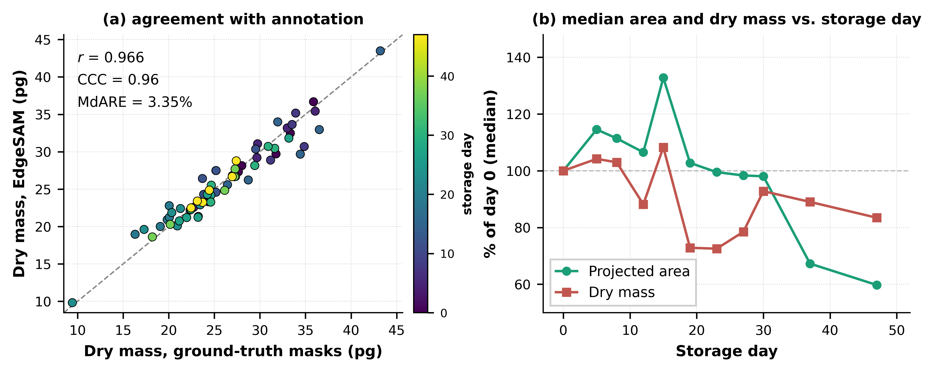
Fig. 8 Phase-derived dry-mass analysis. (a) Per-image median dry-mass estimates derived from EdgeSAM (r = 8) predictions versus those derived from annotation masks, with storage day indicated by color; the dashed line represents the identity line. (b) Median projected area and phase-derived dry mass normalized to their respective day-0 values over the storage period.
- Discussion
The results demonstrate that physics-aware lightweight segmentation can improve the reliability of quantitative holographic cell analysis by treating the predicted cell boundary as a quantitative measurement domain rather than solely as a geometric contour. Conventional segmentation objectives such as Dice and Cross-Entropy primarily optimize spatial agreement between predicted and annotated masks and do not explicitly account for the quantitative phase information enclosed by the predicted boundary. In QPI, however, boundary placement directly determines the region over which the phase signal is integrated for subsequent phase-derived biophysical analysis. The ablation results support this distinction: for EdgeSAM, the full Physics-Aware Phase Consistency Loss reduced the global IPE from 5.22% with Dice-only optimization to 3.04%, while increasing Boundary F1 from 0.938 to 0.953. For MobileNet-UNet, the corresponding IPE decreased from 15.52% to 3.01%. These findings indicate that geometric overlap alone does not fully characterize the suitability of a segmentation mask for quantitative QPI measurements.
The three components of the proposed physics-aware objective provide complementary constraints on the predicted measurement domain. PMC incorporates phase-based foreground information, BGA encourages cellular contours to follow spatial phase transitions, and IPP directly constrains the quantitative phase integrated within the predicted cell region. The component-wise ablation further showed that these constraints must operate together with geometric segmentation objectives. In particular, PMC alone degraded boundary accuracy and minority-class segmentation, whereas the addition of BGA restored boundary localization. Incorporating IPP further reduced global IPE for EdgeSAM and MobileNet-UNet, demonstrating the importance of explicitly considering integrated phase during segmentation optimization. For MobileSAM, the full-objective run did not converge, so the effect of IPP on this architecture could not be established.
Preserving integrated phase is particularly important because segmentation errors propagate directly into downstream phase-derived measurements. Projected area and circularity depend on the predicted cellular boundary, while cellular dry mass is estimated from the phase integrated over the segmented region. Consequently, a segmentation mask with high conventional overlap can still introduce quantitative measurement error if its boundary systematically excludes cellular phase information or includes background regions. This measurement-oriented perspective is especially relevant to RBC storage analysis, where changes in cellular morphology and phase-derived biophysical properties provide complementary information on storage-associated cellular alterations [47, 48]. DHM and QPI are particularly advantageous in this context because they enable label-free quantitative cellular analysis without the staining requirements of conventional imaging approaches. The strong agreement between dry-mass estimates derived from EdgeSAM predictions and annotation masks (r = 0.966, CCC=0.96, MdARE=3.35%, Bland-Altman bias=−0.12 pg) therefore provides direct evidence that the predicted masks can serve as reliable measurement domains for phase-derived quantitative analysis.
The comparison among lightweight architectures and adaptation strategies further demonstrates that computational efficiency must be considered together with segmentation and measurement reliability. LoRA-adapted EdgeSAM maintained non-zero segmentation performance across all four RBC morphologies while providing high boundary fidelity, adequate instance separation, and low IPE. In contrast, full fine-tuning caused severe minority-class degradation in EdgeSAM and MobileSAM despite updating substantially more parameters. These results suggest that restricting adaptation to low-rank parameter updates can provide a favorable regularization effect for relatively small and imbalanced QPI datasets while substantially reducing the number of trainable parameters. The LoRA rank analysis further showed that r = 8 provided the best overall balance among segmentation accuracy, instance separation, integrated-phase preservation, and parameter efficiency.
Computational benchmarking also showed that the selected EdgeSAM configuration is suitable for efficient QPI analysis. ONNX FP16 inference on an NVIDIA RTX A5000 reduced median latency to 4.33 ms and achieved 228.3 FPS with a peak allocated VRAM of 16.4 MB. MobileNet-UNet achieved higher throughput but failed to detect two RBC morphology classes, whereas MobileSAM exhibited poorer instance separation and limited ONNX compatibility. EdgeSAM therefore provided the most balanced combination of quantitative reliability and computational efficiency among the evaluated architectures. These results characterize performance on a desktop-class GPU rather than actual edge-device deployment; validation on low-power embedded platforms will be required to establish real-world edge performance.
The biological analysis further demonstrates the utility of the proposed measurement-oriented segmentation framework. Across the 47-day storage period, the predicted RBC populations exhibited systematic morphological changes, accompanied by a non-monotonic change in projected cell area that peaked at day 15 and declined substantially by day 47. Phase-derived dry mass fluctuated with a significant overall decline that was largely, though not entirely, explained by the concurrent area change. Cellular dry mass was estimated from the integrated quantitative phase using the known illumination wavelength, effective pixel pitch, and specific refractive increment, with the phase scale calibrated to the MCH reference (Section 2.6). This enables direct comparison of phase-derived dry-mass measurements across storage time points and between predicted and annotation-derived measurement boundaries.
Several limitations remain. The LoRA rank and loss configuration were selected using the available validation set, and an independent held-out test cohort was not available. The framework was evaluated only on RBC QPI data, and its generalizability to other cell types, imaging conditions, and densely crowded cellular environments remains to be established. Because phase unwrapping relies on the phase variation remaining within an unambiguous range, specimens with substantially greater optical thickness than RBCs (where the accumulated phase could exceed the unwrapping range) may require additional validation of the reconstruction before this framework is applied. The full physics-aware objective also reduced instance-separation performance relative to Dice-only optimization for EdgeSAM, indicating a remaining trade-off between integrated-phase preservation and individual-cell separation. For MobileSAM, the full-objective ablation run did not converge, so the effect of IPP on this architecture could not be established and should not be assumed to transfer across architectures. In addition, LoRA adaptation was performed offline, and adaptation to changes in imaging conditions or optical aberrations was not investigated. The dataset used in this study provides only the reconstructed phase channel; the corresponding amplitude images were not available, as the original holograms were not retained by the data provider, so incorporating amplitude information was not evaluated in this work. Amplitude images could potentially provide complementary information in the low-phase and boundary regions where segmentation errors were found to concentrate (Section 4.3), and represent a promising direction for future work. Future work will therefore focus on validation using independent QPI datasets and additional cell types, improving instance separation while maintaining integrated-phase preservation, and evaluating the framework on embedded computing platforms.
Overall, the present results establish optical-mass preservation as a measurement-oriented principle for physics-aware QPI segmentation. In this framework, optical-mass preservation is achieved by constraining the integrated quantitative phase within predicted cellular regions rather than by interpreting QPI as a direct measurement of geometric volume. By combining this physical constraint with lightweight architecture design and parameter-efficient adaptation, the proposed framework enables computationally efficient holographic cell segmentation in which predicted boundaries function as physically meaningful measurement domains for subsequent quantitative cellular analysis.
- Conclusion
This study presented a physics-aware lightweight segmentation framework for quantitative holographic cell analysis, in which predicted cell boundaries serve as quantitative measurement domains. The proposed Physics-Aware Phase Consistency Loss explicitly incorporates quantitative phase information into segmentation optimization, enabling integrated-phase preservation beyond conventional geometric segmentation. The physics-aware objective gave clear gains for EdgeSAM and MobileNet-UNet; for MobileSAM, the full-objective run did not converge, so no benefit could be established. Combined with LoRA-based adaptation, the framework achieved reliable RBC segmentation with computationally efficient inference.
Among the evaluated architectures, LoRA-adapted EdgeSAM provided the most balanced performance in segmentation reliability, integrated-phase preservation, and computational efficiency. Application to RBC populations over a 47-day storage period demonstrated storage-associated morphological changes and supported reliable phase-derived dry-mass analysis, with strong agreement between predicted-mask and annotation-derived measurements (r = 0.966).
Overall, the proposed approach demonstrates that optical-mass preservation can be incorporated into lightweight QPI segmentation by explicitly preserving the integrated quantitative phase within predicted cellular regions. This measurement-oriented framework provides a basis for computationally efficient quantitative holographic cell analysis, with future work extending validation to independent QPI datasets, additional cell types, and embedded computing platforms.

Author contributions
Usama Ikram implemented the lightweight segmentation framework, LoRA-based adaptation, and Physics-Aware Phase Consistency Loss; conducted the training, ablation, and computational benchmarking experiments; performed the quantitative phase and statistical analyses; prepared the figures and tables; and wrote the initial draft of the manuscript. Youhyun Kim contributed to the quantitative phase imaging experiments, data preparation, and interpretation of the quantitative holographic cell analysis results, and reviewed the manuscript. Inkyu Moon conceived and supervised the study, provided expertise in digital holographic microscopy and quantitative phase imaging, provided the red blood cell storage dataset and computational resources, guided the interpretation of the results, and reviewed and edited the manuscript. All authors read and approved of the final manuscript.

Funding
This work was supported by the National Research Foundation of Korea (NRF) grant funded by the Korean government (MSIT) in 2026 (Grant No. RS-2026-25611334, Project Title: AI Mechanician: A Physics- and Math-Based AI that Identifies and Unifies Multi-Transport Phenomena in Irregular Porous Media from Visualization). This work was supported by the InnoCORE program of the Ministry of Science and ICT (26-InnoCORE-02).

Data availability
The data generated and/or analyzed during the current study are available from the corresponding author upon reasonable request.

Declarations
Conflict of interest
The authors declare that they have no competing interests.
Ethics approval and consent to participate
Blood samples were collected from three healthy donors under a protocol approved by the Institutional Review Board of DGIST (Approval No. DGIST-180713-BR-012-01), and informed consent was obtained from all donors.
Consent for publication
Not applicable.

References
[1] D. Gabor, A new microscopic principle. Nature 161, 777-778 (1948).
[2] A. Beléndez, J. T. Sheridan, and I. Pascual, Celebrating holography anniversaries: a historical perspective. Proc. SPIE 12151, 1215102 (2022).
[3] E. N. Leith and J. Upatnieks, Reconstructed wavefronts and communication theory. J. Opt. Soc. Am. 52(10), 1123-1130 (1962).
[4] J. W. Goodman and R. W. Lawrence, Digital image formation from electronically detected holograms. Appl. Phys. Lett. 11, 77-79 (1967).
[5] U. Schnars and W. Jüptner, Direct recording of holograms by a CCD target and numerical reconstruction. Appl. Opt. 33, 179-181 (1994).
[6] R. Kumar and G. Dwivedi, Emerging scientific and industrial applications of digital holography: an overview. Eng. Res. Express 5(3), 032005 (2023).
[7] B. Javidi, A. Carnicer, A. Anand, et al., Roadmap on digital holography. Opt. Express 29(22), 35078-35118 (2021).
[8] T. Tahara, X. Quan, R. Otani, Y. Takaki, and O. Matoba, Digital holography and its multidimensional imaging applications: a review. Microscopy 67(2), 55-67 (2018).
[9] Z. Huang and L. Cao, Quantitative phase imaging based on holography: trends and new perspectives. Light Sci. Appl. 13(1), 145 (2024).
[10] P. Gao and C. Yuan, Resolution enhancement of digital holographic microscopy via synthetic aperture: a review. Light Adv. Manuf. 3, 6 (2022).
[11] W. Xu, M. Jericho, I. Meinertzhagen, and H. Kreuzer, Digital in-line holography for biological applications. Proc. Natl. Acad. Sci. 98(20), 11301-11305 (2001).
[12] I. Moon and B. Javidi, 3-D visualization and identification of biological microorganisms using partially temporal incoherent light in-line computational holographic imaging. IEEE Trans. Med. Imaging 27(12), 1782-1790 (2008).
[13] E. M. Mihaylova, Imaging of live cells by digital holographic microscopy. Photonics 11, 980 (2024).
[14] B. Kemper and G. V. Bally, Digital holographic microscopy for live cell applications and technical inspection. Appl. Opt. 47(4), A52-A61 (2008).
[15] Y. Park, C. Depeursinge, and G. Popescu, Quantitative phase imaging in biomedicine. Nat. Photonics 12(10), 578-589 (2018).
[16] J. Park, B. Bai, D. Ryu, et al., Artificial intelligence-enabled quantitative phase imaging methods for life sciences. Nat. Methods 20(11), 1645-1660 (2023).
[17] T. Cacace, V. Bianco, and P. Ferraro, Quantitative phase imaging trends in biomedical applications. Opt. and Lasers Eng. 135, 106188 (2020).
[18] Y. Cotte, F. Toy, P. Jourdain, et al., Marker-free phase nanoscopy. Nat. Photonics 7(2), 113-117 (2013).
[19] T. L. Nguyen, S. Pradeep, R. L. Judson-Torres, et al., Quantitative phase imaging: recent advances and expanding potential in biomedicine. ACS Nano 16(8), 11516-11544 (2022).
[20] S. Aknoun, J. Savatier, P. Bon, et al., Living cell dry mass measurement using quantitative phase imaging with quadriwave lateral shearing interferometry: an accuracy and sensitivity discussion. J. Biomed. Opt. 20(12), 126009 (2015).
[21] M. E. Kandel, Y. R. He, Y. J. Lee, et al., Phase imaging with computational specificity (PICS) for measuring dry mass changes in sub-cellular compartments. Nat. Commun. 11, 6256 (2020).
[22] A. Anand, I. Moon, and B. Javidi, Automated disease identification with 3-D optical imaging: a medical diagnostic tool. Proc. IEEE 105(5), 924-946 (2017).
[23] M. Jiang, M. Shao, X. Yang, et al., Automatic classification of red blood cell morphology based on quantitative phase imaging. Int. J. Opt. 2022, 1240020 (2022).
[24] C. Roussel, M. Dussiot, M. Marin, et al., Spherocytic shift of red blood cells during storage provides a quantitative whole cell-based marker of the storage lesion. Transfusion 57(4), 1007-1018 (2017).
[25] K. Jaferzadeh and I. Moon, Quantitative investigation of red blood cell three-dimensional geometric and chemical changes in the storage lesion using digital holographic microscopy. J. Biomed. Opt. 20(11), 111218 (2015).
[26] E. Kim, S. Park, S. Hwang, I. Moon, and B. Javidi, Deep learning-based phenotypic assessment of red cell storage lesions for safe transfusions. IEEE J. Biomed. Health Inform. 26(3), 1318-1328 (2021).
[27] Y. Jo, H. Cho, S. Y. Lee, et al., Quantitative phase imaging and artificial intelligence: a review. IEEE J. Sel. Top. Quantum Electron. 25(1), 6800914 (2019).
[28] F. Yi, I. Moon, B. Javidi, et al., Automated segmentation of multiple red blood cells with digital holographic microscopy. J. Biomed. Opt. 18(2), 026006 (2013).
[29] I. Moon, K. Jaferzadeh, E. Ahmadzadeh, et al., Automated quantitative analysis of multiple cardiomyocytes at the single-cell level with three-dimensional holographic imaging informatics. J. Biophotonics 11(12), e201800116 (2018).
[30] F. Yi, I. Moon, B. Javidi, et al., Cell morphology-based classification of red blood cells using holographic imaging informatics. Biomed. Opt. Express 7(6), 2385-2399 (2016).
[31] R. Poudel, S. Liwicki, and R. Cipolla, Fast-SCNN: Fast semantic segmentation network. arXiv:1902.04502 (2019).
[32] B. Bag, H. Maity, and C. Koley, UNet MobileNetV2: Medical image segmentation using deep neural network (DNN). J. Mech. Contin. Math. Sci. 18(1), 21-29 (2023).
[33] C. Zhang, D. Han, Y. Qiao, et al., Faster Segment Anything: Towards lightweight SAM for mobile applications. arXiv:2306.14289 (2023).
[34] C. Zhou, X. Li, C. Loy, and B. Dai, EdgeSAM: Prompt-in-the-loop distillation for on-device deployment of SAM. arXiv:2312.06660 (2023).
[35] M. Jia, L. Tang, B. Chen, et al., Visual prompt tuning. In European Conference on Computer Vision (2022).
[36] E. Hu, Y. Shen, P. Wallis, et al., LoRA: Low-rank adaptation of large language models. Int. Conf. Learn. Represent. (ICLR) (2022).
[37] S. Park, J. Lee, J. Park, and I. Moon, HoloFluoNet: Live cell imaging intelligence based on fused holography and fluorescence for virtual staining, cell segmentation, classification, and viability analysis. Eng. Appl. Artif. Intell. 161, 112323 (2025).
[38] O. Russakovsky, J. Deng, H. Su, et al., ImageNet large scale visual recognition challenge. Int. J. Comput. Vis. 115(3), 211-252 (2015).
[39] B. Rappaz, P. Marquet, E. Cuche, et al., Measurement of the integral refractive index and dynamic cell morphometry of living cells with digital holographic microscopy. Opt. Express 13(23), 9361-9373 (2005).
[40] I. Moon and B. Javidi, AI-driven digital holographic microscopy for label-free quantitative cellular analysis: toward low-cost and field-deployable platforms. Biomed. Opt. Express 17(5), 2349-2370 (2026).
[41] C. Nguyen and T. Hy, Efficient deep learning for medical imaging: Bridging the gap between high-performance AI and clinical deployment. arXiv:2602.00910 (2026).
[42] Y. Xu, T. M. Khan, Y. Song, and E. Meijering, Edge deep learning in computer vision and medical diagnostics: a comprehensive survey. arXiv:2605.06714 (2026).
[43] A. E. G. Madsen, M. A. Panah, P. E. Larsen, F. Nielsen, and J. Glückstad, On-axis digital holographic microscopy: current trends and algorithms. Opt. Commun. 537, 129458 (2023).
[44] I. Moon, F. Yi, Y. Lee, et al., Automated quantitative analysis of 3D morphology and mean corpuscular hemoglobin in human red blood cells stored in different periods. Opt. Express 21(25), 30947-30957 (2013).
[45] L. I.-K. Lin, A concordance correlation coefficient to evaluate reproducibility. Biometrics 45(1), 255-268 (1989).
[46] J. M. Bland and D. G. Altman, Statistical methods for assessing agreement between two methods of clinical measurement. Lancet 1(8476), 307-310 (1986).
[47] S. Rogers, X. Ge, M. Brummet, et al., Quantifying dynamic range in red blood cell energetics: Evidence of progressive energy failure during storage. Transfusion 61(5), 1586-1599 (2021).
[48] M. Bardyn, B. Rappaz, K. Jaferzadeh, et al., Red blood cells ageing markers: a multi-parametric analysis. Blood Transfusion 15(3), 239 (2017).

